***DOCO-Hub***

A Report

Submitted in the partial fulfillment of the requirements for

the award of Degree of B. Tech

***By***

***student name-1(roll no)***

***student name-2(roll no)***

Under the Supervision of:-

Mr./Dr. Guide Name

(Designation, Department of CSE)

Department of Computer Science ***&*** Engineering

Vidya College of Engineering

Meerut – 250 005



Dr. A.P.J. Abdul Kalam Technical University, U.P., Lucknow

2016-2020

***Project***

***REPORT***

**TABLE OF CONTENT**

**Page No.**

**DECLARATION** **i**

**CERTIFICATE** **ii**

**ACKNOWLEDGEMENTS** **iii**

**ABSTRACT** **iv**

**LIST OF TABLES** ……………………………………………………………... **v**

**LIST OF FIGURES** ...…………………………………………………………... **vi**

**CHAPTER 1 INTRODUCTION** …..…………………………………………… 1

1.1 INTRODUCTION………...……………………………………………. 10

1.2 SCOPE…………………………………………………………………... 11

1.3 SOFTWARE DEVELOPMENT METHODOLOGY………………….. 12

**CHAPTER 2 EFFORT AND COST ESTIMATION**………………………….. 14

**CHAPTER 3 SOFTWARE REQUIREMENTS SPECIFICATION**………….. 17

3.1 INTRODUCTION………………………………………………………. 17

3.2 INTENDED AUDIENCE AND READING SUGGESTIONS………….. 17

3.3 GENERAL ARCHITECTURE OF SOFTWARE………………………. 18

3.4 REQUIREMENT SPECIFICATION………………………….................. 19

3.4.1 FUNCTIONAL REQUIREMENTS……………………………... 19

3.4.2 NON-FUNCTIONAL REQUIREMENTS………………………. 19

3.5 FEASIBILITY STUDY…………………………………………………. 20

3.5.1 OPERATIONAL FEASIBILITY……………………………….. 20

3.5.2 TECHNICAL FEASIBILITY…………………………………... 20

3.4.3 ECONOMIC FEASIBILITY…………………………………… 20

3.6 SYSTEM REQUIREMENTS STUDY…………………………………… 21

3.6.1 SOFTWARE REQUIREMENTS……………………………….. 21

3.6.2 HARDWARE REQUIREMENTS……………………………... 21

3.7 USER REQUIREMENT DOCUMENT (URD)………………………….. 22

3.7.1 USE-CASE DIAGRAM………………………………………… 22

3.7.2 ACTIVITY DIAGRAM ………………………………………. … 23

3.8 SYSTEM DESIGN ……………………………………………………... 26

3.8.1 INTRODUCTION…………………………………………………. 26

3.8.2 DATA FLOW DIAGRAM ………………………………...... 26

|  |  |  |
| --- | --- | --- |
| 3.8.3 | SEQUENCE DIAGRAM……………………………………….. | 28 |
| 3.8.4 | CLASS DIAGRAM…………………………………………….. | 30 |
| **CHAPTER 4 SCREENSHOTS**………………………………………………… | | 31 |
| **CHAPTER 5 TECHNOLOGY USED**…………………………………………. | | 44 |
| 5.1 | JAVA…………………………………………………………… | 44 |
| **CHAPTER 6 TESTING AND INTEGRATION**……………………………… | | 50 |
| 6.1. TEST CASE DESCRIPTION …………………………… | |  |
| 6.2. TYPES OF TESTING……………………………….. | | 50 |
| 6.3. TEST CASES ……………………………………… | | 53 |
| 6.4. FUTURE ENHANCEMENT ……………………. | | 56 |
| **CONCLUSION** ………………………………………………………………… | | 57 |
| **REFERENCES**………………………………………………………………. | | 58 |

**APPENDIX**…………………………………………………………………………………….. A

***DECLARATION***

*I declare that this project report titled DOCO-Hub submitted in partial fulfillment of the degree of B. Tech in (Computer Science & Engineering) is a record of original work carried out by me under the supervision of <Name(s) of the Supervisor(s)>, and has not formed the basis for the award of any other degree or diploma, in this or any other Institution or University. In keeping with the ethical practice in reporting scientific information, due acknowledgements have been made wherever the findings of others have been cited.*

*Signature :*

*Name* *:*

*Roll No. :*

*Date* *:*

*Signature :*

*Name* *:*

*Roll No. :*

*Date* *:*

**CERTIFICATE**

This is to certify that *Project Report entitled ―DOCO-Hub* which is submitted by *student-name1 (roll no), student-name2 (roll no), student-name3 (roll no)* in partial fulfillment of the requirement for the award of degree B. Tech. in Department of …….. Of Dr. A.P.J. Abdul Kalam Technical University, U.P., Lucknow., is a record of the candidate own work carried out by him/her under my/our supervision. The matter embodied in this Project report is original and has not been submitted for the award of any other degree.

**Date:** **Supervisor**

**ACKNOWLEDGEMENTS**

*It gives us a great sense of pleasure to present the report of the B. Tech Project undertaken during B.Tech. Final Year. We owe special debt of gratitude to our guide Prof. (Dr.) Guide Name, Department of …………., Vidya College of Engineering, Meerut for his constant support and guidance throughout the course of our work. His sincerity, thoroughness and perseverance have been a constant source of inspiration for us. It is only his cognizant efforts that our endeavors have seen light of the day.*

*We also do not like to miss the opportunity to acknowledge the contribution of all faculty members of the department for their kind assistance and cooperation during the development of our project. Last but not the least, we acknowledge our friends for their contribution in the completion of the project.*

|  |  |  |
| --- | --- | --- |
| *Signature :* | | *Signature:* |
| *Name* | *:* | *Name:* |
| *Roll No.* | *:* | *Roll No:* |
| *Date* | *:* | *Date:* |

**Abstract**

Life is becoming too busy to get medical appointments in person and to maintain a proper health care. The main idea of this work is to provide ease and comfort to patients while taking appointment from doctors and it also resolves the problems that the patients has to face while making an appointment. The application DOCO-Hub acts as a mediator between doctor and patient whereas the database containing the doctor’s details, patient’s details and appointment details is maintained by a website that acts as a server.

If anybody is ill and wants to visit a doctor for checkup, he or she needs to visit the hospital and waits until the doctor is available. The patient also waits in a queue while getting appointment. If the doctor cancels the appointment for some emergency reasons then the patient is not able to know about the cancelation of the appointment unless or until he or she visits the hospital. As the mobile communication technology is developing rapidly, therefore, one can use the mobile’s applications to overcome such problems and inconvenience for the patients. There is much work in the literature in this regard [1-14]. An intelligent agent based appointment system has been proposed in which a scheduling system is provided for patients. The junior medical staff schedules appointment according to the priority level proposed solution is a website that is used to Search doctors and hospitals along with other details. Some online systems that are already functional still have some drawbacks. To overcome these drawbacks an online patient appointment system is proposed using Client Server technique and web enabled mobile application.

**LIST OF FIGURES**

|  |  |  |
| --- | --- | --- |
| **S.NO** | **DESCRIPTION** | **PAGE NO.** |
|  |  |  |
| **3.3** | General Architecture of Software | **18** |
|  |  |  |
| **3.7.1** | Use Case Diagram | **22** |
|  |  |  |
| **3.7.2** | Activity Diagram | **24** |
|  |  |  |
| **3.8.2** | Data Flow Diagram | **27** |
|  |  |  |
| **3.8.3.1** | Interaction with Face pager | **28** |
|  |  |  |
| **3.8.3.2** | Browsing the input | **29** |
|  |  |  |
| **3.8.3.3** | Interaction with dictionary | **29** |
|  |  |  |
| **3.8.4** | Class Diagram | **30** |
|  |  |  |
| **4.1** | Homepage | **31** |
|  |  |  |
| **4.2** | Browse the file | **32** |
|  |  |  |
| **4.3** | HTML file chosen | **33** |
|  |  |  |
| **4.4** | Showing alert | **34** |
|  |  |  |
| **4.5** | CSV file chosen | **35** |
|  |  |  |
| **4.6** | Showing input file | **36** |
|  |  |  |
| **4.7** | Choose the domain | **37** |
|  |  |  |
| **4.8** | Happy feeling chosen | **38** |
|  |  |  |
| **4.9** | Displaying result | **39** |
|  |  |  |
| **4.10** | Sad feeling chosen | **40** |
|  |  |  |
| **4.11** | Showing result | **41** |
|  |  |  |
| **4.12** | No feeling chosen | **42** |
|  |  |  |
| **4.13** | Invalid input | **43** |
|  |  |  |

***Chapter-1***

***1.1 INTRODUCTION***

***Problem Statement***

Globally, health care sector is the pivot and integral part of human lives. Thus, any error committed in the clinical services might leads to defect or termination of life. Recently, information and Communication has been used extensively to improve the various operations and services in the field of the health care service. Patient appointment with the Doctor is one of the clinical services that have been automated. Healthcare providers are motivated to reduce operation cost while improving the quality of service. This has given rise to preventive medicine in order to avoid disease, lessening the demand for emergency department and hospital stays for sick people. The importance of Patient Scheduling cannot be underestimated in the health care delivery landscape. Patient scheduling is a complex process that perform a crucial role in health care. Patient scheduling performs several functions, from allocating resources to patients in need of exams and allocation of surgery rooms to on-demand appointment scheduling with Family Doctors working at Primary Care clinics. A good appointment scheduling system encourages patient and physician satisfaction, and as such, is an important component of healthcare. The efficiency of health care delivery hinged solely on the effectiveness of the Patient scheduling system. it reduces medical error among practitioner and also reduce the number of unsatisfied patient. Appointment systems have been extensively used to reduce patient waiting times and waiting-room congestion.Such systems have the potential to increase access to medical resources while reducing cost, as well as staff and patient dissatisfaction derived from unmet schedule constraints. The main aim of optimal patient scheduling is to determine an appointment technique for which a particular measure of performance is optimized under uncertain conditions.Appointment scheduling system is a system for planning of appointments between resources such as patients, facilities and providers. It is used in order to minimize waiting times, prioritize appointments and optimize the utilization of resources. Angular JS is an extensible and exciting new JavaScript MVC framework developed by Google for building well-designed, structured and interactive single-page applications (SPA). It lays strong emphasis on Testing and Development best practices such as templating and declarative bi-directional data binding. The framework is used to create rich and interactive SPA's(Single page Architecture).The framework consists of several core and optional libraries. In this project ,an appointment and scheduling system is designed to reduce time waiting and ensure optimal use of clinical resources. The proposed system uses PHP framework for the front end design and PHP for the server side logic

**1.2 Scope of the Project**

The project is related to the Doctor Patient Appointment System, We will develop this project as prototype.

But after some changes and improving the configuration of the server we can use this for State or for Whole Country.

***1.3 Methodology Used in the Project:***

**There are various methodologies available for Project Implementation, but we can choose the methodology according to our project and experience. We are new and can’t solve the problem in one shot.**

**Therefore we will use RAD Model to implement the project, in this method we can check and verify each step multiple times and also can get back to review the older stage of the project.**

**Chapter-2**

**Effort and Cost Estimation**

Software will take appx following time in each phase:

1. Problem Study 7 Days
2. Project Outlining 7 Days
3. Database Designing 2 Days
4. Study of the Existing Solutions 5 Days
5. Designing of Interfaces 10 Days
6. Coding 45 Days
7. Testing/ Change 5 Days
8. Implementation 30 Days
9. Documentation 15 Days
10. Initial Maintenance 25 Days

Total 120 Days

Assuming 20,000 Per Month employee cost

Cost: 80,000

Hardware Cost: 30,000

Domain Registration + Hosting 10,000

Total Cost: 1,00,000/-

(One Lakh only)

***Chapter 3***

***Software Requirement Specification***

**3.1 Introduction**

Starting the project, we should fully know about the meaning of project. There are seven letters in the word ***“PROJECT”.*** Each character has its own technical meaning.

***P – planning :*** this deals with the idea at thinking and which are required for project.

***R – Resource :*** the money problem will be solved and resources from which collected.

***O – Operating :*** the procedure from which getting job is prepared in a systematic way is known as operation.

***J – Joint effort :*** this is directly proper to a operation output is a made of several person working sincerely is known as JOIN EFFORT.

***E – Engineering : A*** well educated engineer can do this work in a better way to find out better result. Hence the project is as engineer function.

***C – Cooperation :*** To make the project successfully, it is necessary for its success and completion of project.

***T – Technique :*** It must as it gives a better shape. It is not possible to complete the project without technique.

***The project is a system that gives the systematic way of planning and working.***

***Or***

***It representing the temporary task, in a scientific manner carried out of engineers to achieve a goal.***

**3.2 Intended Audience and Reading Suggestions:**

This software is designed for the prisoners, Police Department and General Public can use this software.

We have studied multiple books to learn the PHP Concept. HTML, Javascript and CSS are also essential, therefore we have also studied them.

**3.3 General Architecture of the Software:**

This application is based on Client Server Architecture.

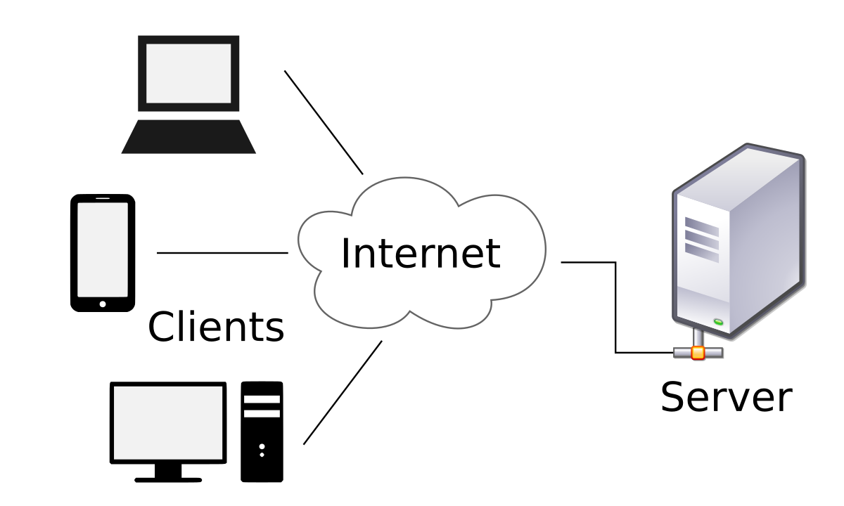

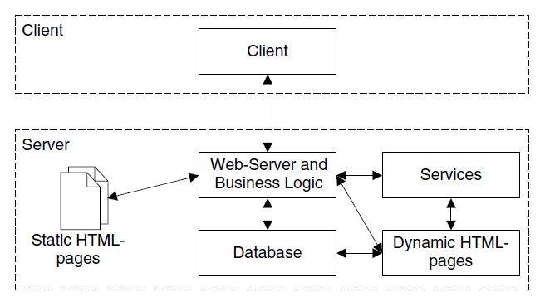

**3.4 Requirement Specification**

## 3.4.1 What is a Functional Requirement?

In software engineering, a functional requirement defines a system or its component. It describes the functions a software must perform. A function is nothing but inputs, its behavior, and outputs. It can be a calculation, data manipulation, business process, user interaction, or any other specific functionality which defines what function a system is likely to perform.

Functional software requirements help you to capture the intended behavior of the system. This behavior may be expressed as functions, services or tasks or which system is required to perform.

## Example of Functional Requirements

* The software automatically validates customers against the ABC Contact Management System
* The Sales system should allow users to record customers sales
* The background color for all windows in the application will be blue and have a hexadecimal RGB color value of 0x0000FF.
* Only Managerial level employees have the right to view revenue data.
* The software system should be integrated with banking API

## 3.4.2 What is Non-Functional Requirement?

A non-functional requirement defines the quality attribute of a software system. They represent a set of standards used to judge the specific operation of a system. Example, how fast does the website load?

A non-functional requirement is essential to ensure the usability and effectiveness of the entire software system. Failing to meet non-functional requirements can result in systems that fail to satisfy user needs.

Non-functional Requirements allows you to impose constraints or restrictions on the design of the system across the various agile backlogs. Example, the site should load in 3 seconds when the number of simultaneous users are > 10000. Description of non-functional requirements is just as critical as a functional requirement.

## Examples of Non-functional requirements

Here, are some examples of non-functional requirement:

1. Users must change the initially assigned login password immediately after the first successful login. Moreover, the initial should never be reused.
2. Employees never allowed to update their salary information. Such attempt should be reported to the security administrator.
3. Every unsuccessful attempt by a user to access an item of data shall be recorded on an audit trail.
4. A website should be capable enough to handle 20 million users with affecting its performance
5. The software should be portable. So moving from one OS to other OS does not create any problem.
6. Privacy of information, the export of restricted technologies, intellectual property rights, etc. should be audited.

**3.5 Feasibility Study**

Any new project, product, process or business venture has to be thoroughly analyzed in a comprehensive feasibility study before a decision is made to go ahead or not. What is feasibility studies? A feasibility study is a comprehensive report about a project that details clearly the strengths, opportunities, weaknesses and threats of a given business undertaking and whether or not the company has the required resources, legal wiggle room and the technical capacity to undertake the project as designed. Different types of feasibility studies address a different aspect of a project. In case the project is not viable then the project is either redesigned, cancelled or modified to accommodate the requirements dictated by the study.

What are the types of feasibility studies?

Aside from the five major ones there are many other types of feasibility studies. Here is a list of the major five, followed by the various types of feasibility studies that are not covered in the major types.

**3.5.1 Technical feasibility**

Technical feasibility is the assessment of the technical requirements of a project or product to find out what technical resources a project requires. Technical feasibility is not complete until the same technical assessment is done on the company to establish that it has the technical capabilities to carry out the implementation of the project to completion within the required time. It is focused on the available hardware and software to be used for a project.

**3.5.2 Legal feasibility**

This is an assessment of whether the project meets the legal requirements that exist for implementation. An example is whether a new building meets the requirements of the law, whether the location was suitably chosen and construction is approved by the authorities. Legal feasibility also encompasses the ethical aspects of a project, for example does a new plant dump its waste in a manner that is environmentally friendly. The project may also be a new undertaking that is not covered under any law and so this must also be checked. Read

**3.5.3 Operational feasibility**

Operational feasibility ascertains how well the implementation of a project fits in with the current organizational business structure. The solutions to a current problem must come as close as possible to a perfect fit with the organizational structure and be able to be applied to solve other arising problems. The opportunities that come along the way during the solution implementation must be able to be harnessed for even easier implementation.

**3.5.4 Economic feasibility**

Here, a study is done on the project to see how long it would take for the project to reach break-even point. It is similar to a cost benefit analysis. Every project incurs a cost and it is prudent for financial planning purposes to know exactly when to expect returns. Also, to anticipate the capital required to complete the project. This is not limited to for-profit projects only as they will also incur a financial cost.

3.6 Hardware/Software requirement of project are :

|  |  |
| --- | --- |
| **Section** | **Requirements and Recommendations** |
| Supported Operating Systems | Microsoft Windows 7 32/64 bit  Microsoft Windows 8 32/64 bit |
| Additional Software Requirements | MY Sql  Apache Server |
| Display | Minimum resolution 800 x 600 pixel  1024 x 768 pixel recommended |
| RAM | 2 GB or more  4 GB or more recommended especially for Microsoft Windows Vista, 7 and 8 |
| CPU | 1.5 GHz processor speed or higher |
| Tools: | XAMPP |
| Web Language | HTML, Javascript and CSS |
| Primary Language | PHP |

**3.7 User Requirement Document (URD)**

The user requirement(s) document (URD) or user requirement(s) specification (URS) is a document usually used in software engineering that specifies what the user expects the software to be able to do.

Once the required information is completely gathered it is documented in a URD, which is meant to spell out exactly what the software must do and becomes part of the contractual agreement. A customer cannot demand features not in the URD, while the developer cannot claim the product is ready if it does not meet an item of the URD.

The URD can be used as a guide to planning cost, timetables, milestones, testing, etc. The explicit nature of the URD allows customers to show it to various stakeholders to make sure all necessary features are described.

Formulating a URD requires negotiation to determine what is technically and economically feasible. Preparing a URD is one of those skills that lies between a science and an art, requiring both software technical skills and interpersonal skills.

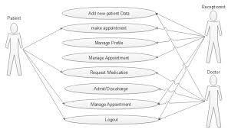

**3.8 System Design**

**3.8.1 Introduction**

Systems design is the process of defining the architecture, modules, interfaces, and data for a system to satisfy specified requirements. Systems design could be seen as the application of systems theory to product development. There is some overlap with the disciplines of systems analysis, systems architecture and systems engineering.

If the broader topic of product development "blends the perspective of marketing, design, and manufacturing into a single approach to product development," then design is the act of taking the marketing information and creating the design of the product to be manufactured. Systems design is therefore the process of defining and developing systems to satisfy specified requirements of the user.

The basic study of system design is the understanding of component parts and their subsequent interaction with one another.

Until the 1990s, systems design had a crucial and respected role in the data processing industry. In the 1990s, standardization of hardware and software resulted in the ability to build modular systems. The increasing importance of software running on generic platforms has enhanced the discipline of software engineering.

### Architectural design

The architectural design of a system emphasizes the design of the system architecture that describes the structure, behavior and more views of that system and analysis.

### Logical design

The logical design of a system pertains to an abstract representation of the data flows, inputs and outputs of the system. This is often conducted via modelling, using an over-abstract (and sometimes graphical) model of the actual system. In the context of systems, designs are included. Logical design includes entity-relationship diagrams (ER diagrams).

### Physical design

The physical design relates to the actual input and output processes of the system. This is explained in terms of how data is input into a system, how it is verified/authenticated, how it is processed, and how it is displayed. In physical design, the following requirements about the system are decided.

1. Input requirement,
2. Output requirements,
3. Storage requirements,
4. Processing requirements,
5. System control and backup or recovery.

Put another way, the physical portion of system design can generally be broken down into three sub-tasks:

1. User Interface Design
2. Data Design
3. Process Design

User Interface Design is concerned with how users add information to the system and with how the system presents information back to them. Data Design is concerned with how the data is represented and stored within the system. Finally, Process Design is concerned with how data moves through the system, and with how and where it is validated, secured and/or transformed as it flows into, through and out of the system. At the end of the system design phase, documentation describing the three sub-tasks is produced and made available for use in the next phase.

Physical design, in this context, does not refer to the tangible physical design of an information system. To use an analogy, a personal computer's physical design involves input via a keyboard, processing within the CPU, and output via a monitor, printer, etc. It would not concern the actual layout of the tangible hardware, which for a PC would be a monitor, CPU, motherboard, hard drive, modems, video/graphics cards, USB slots, etc. It involves a detailed design of a user and a product database structure processor and a control processor. The H/S personal specification is developed for the proposed system.

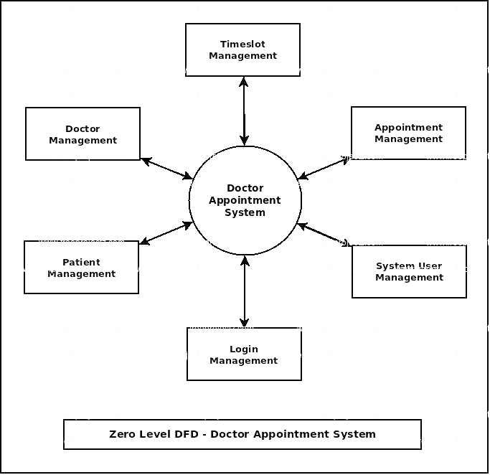

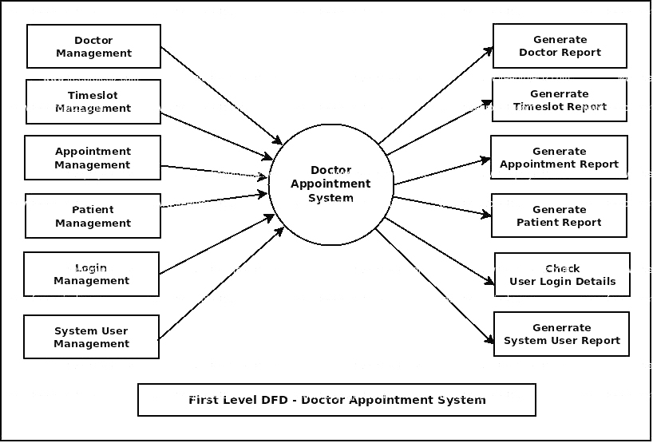

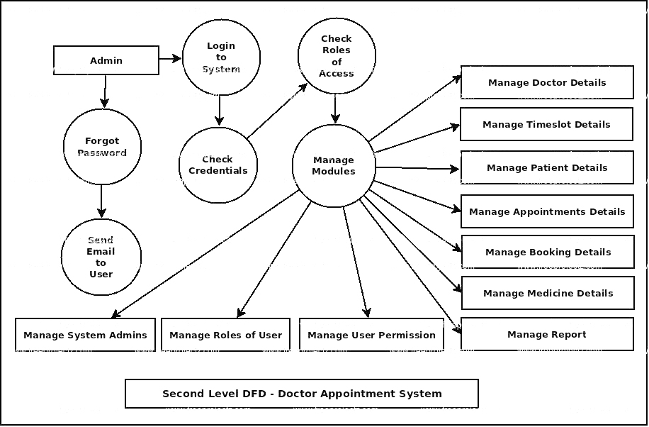

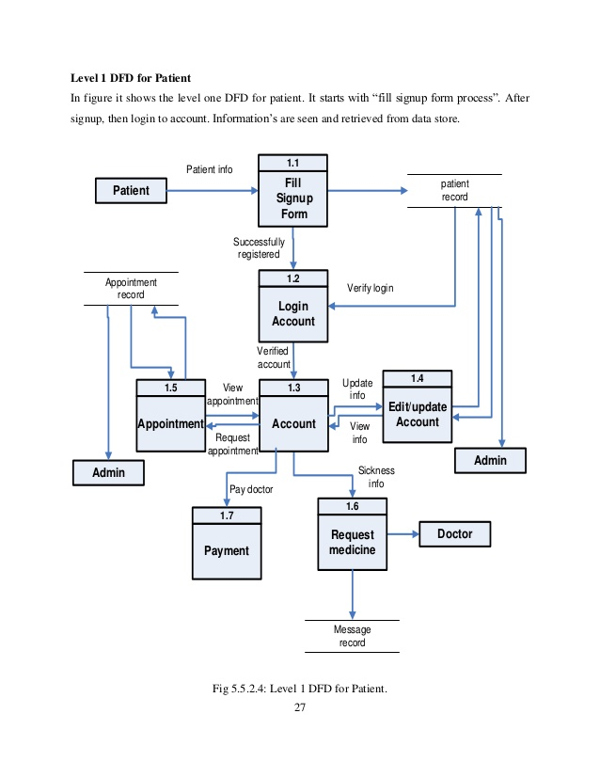

**Chapter 4**

**Screenshots**

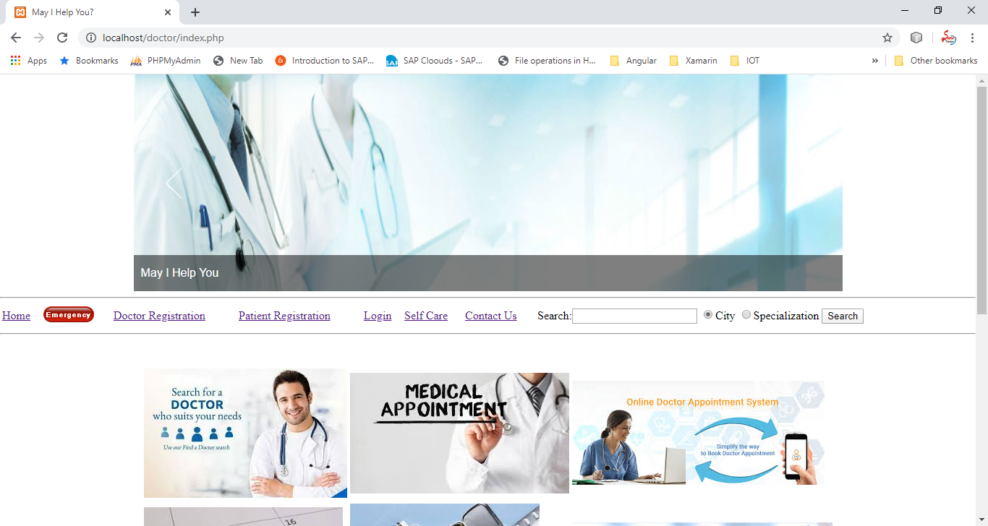

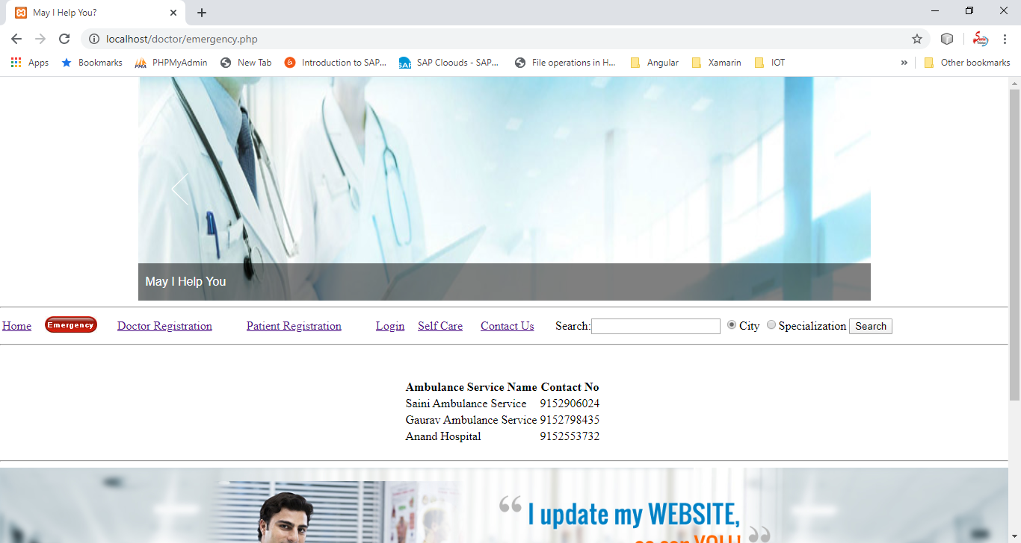

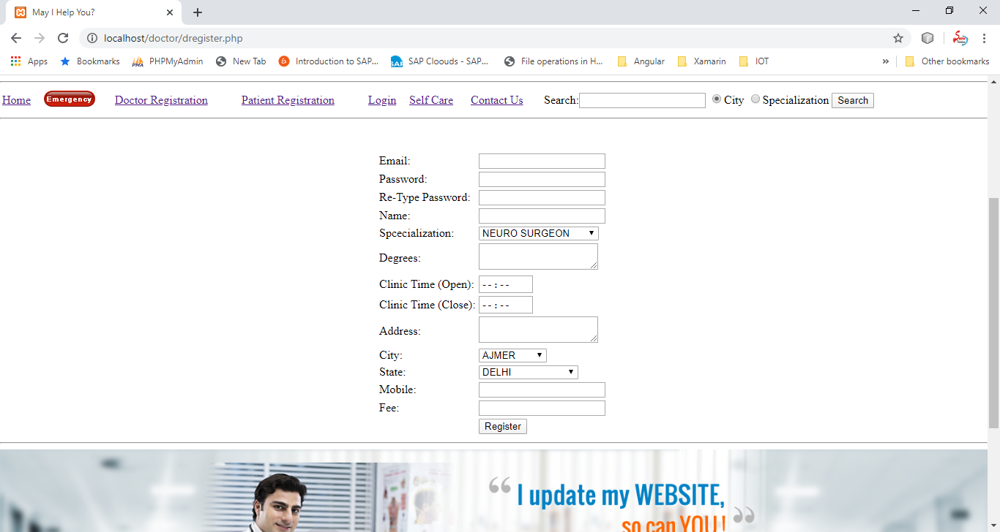

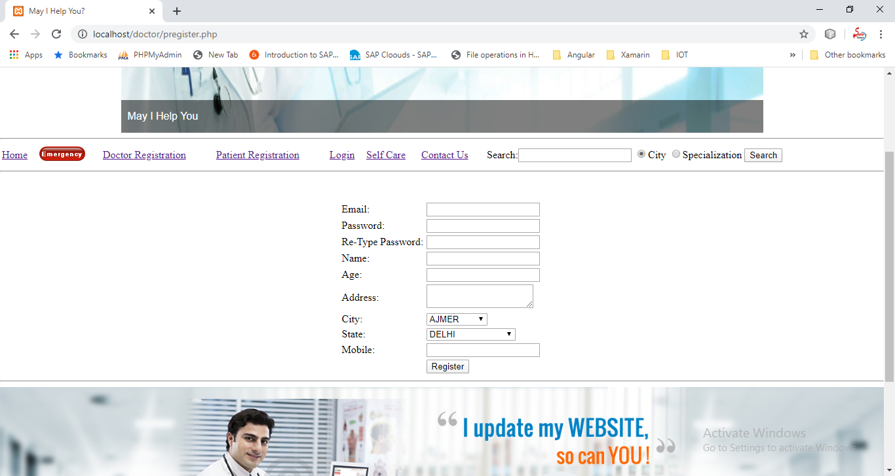

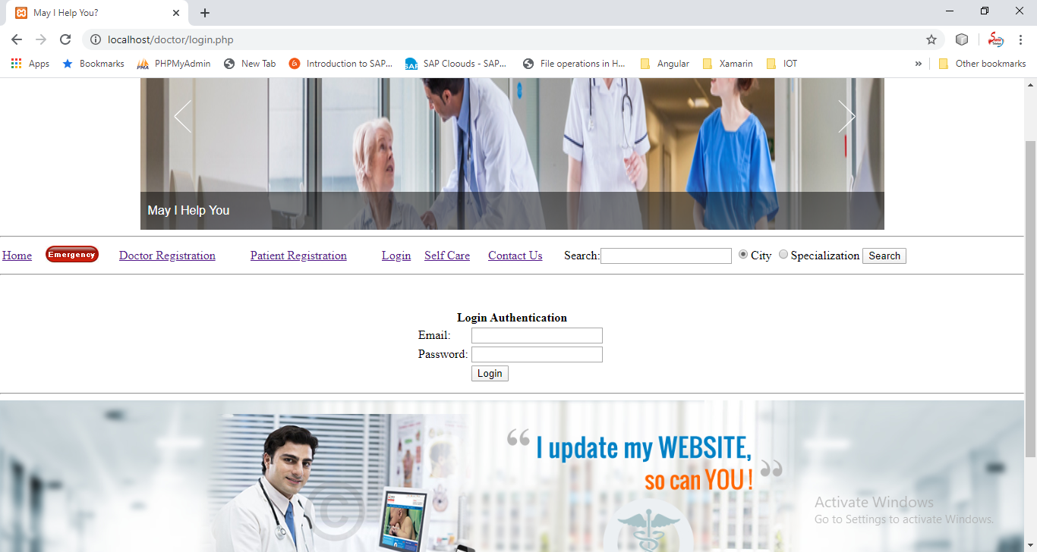

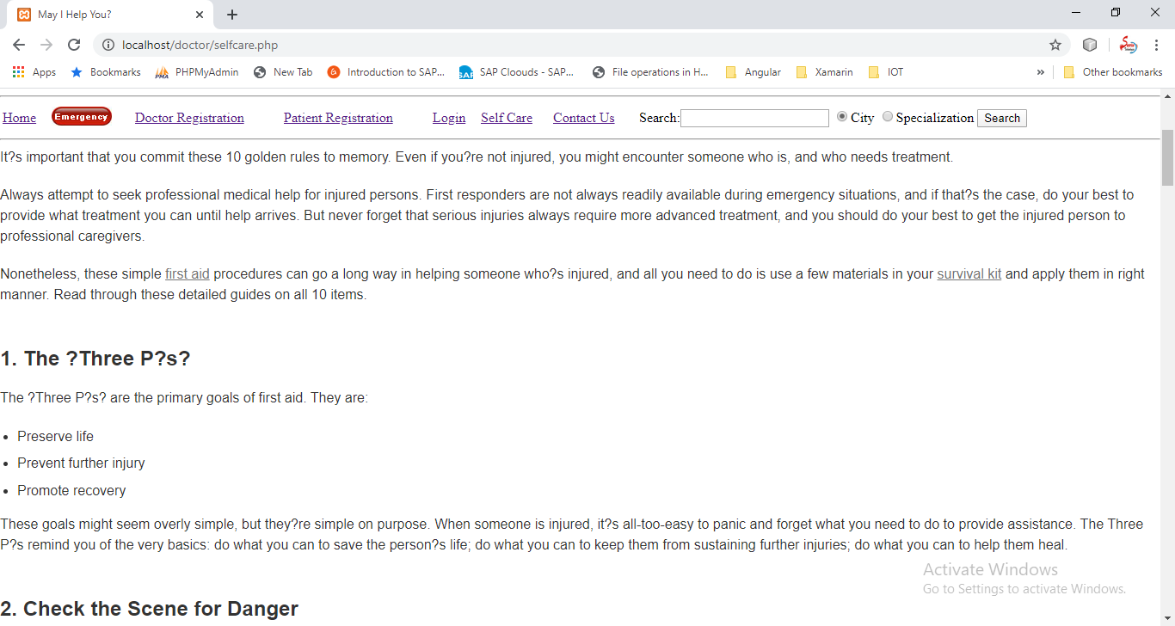

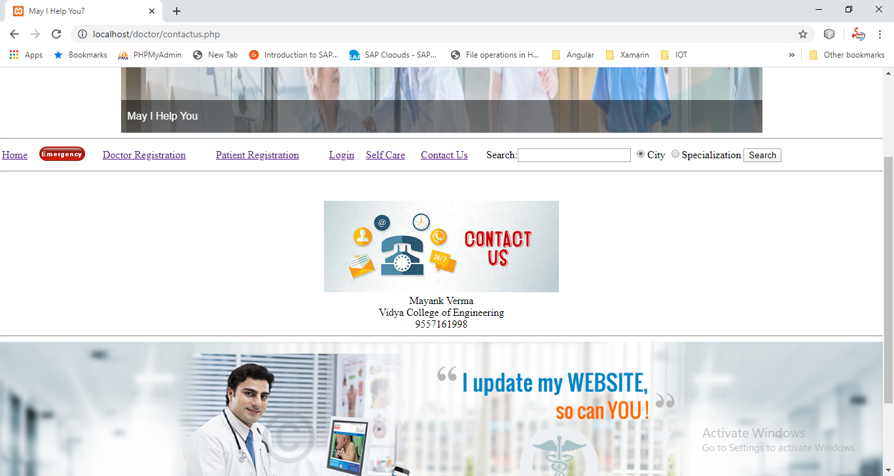

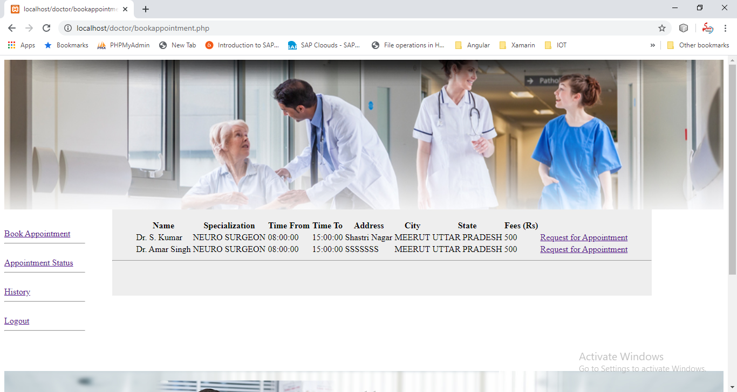

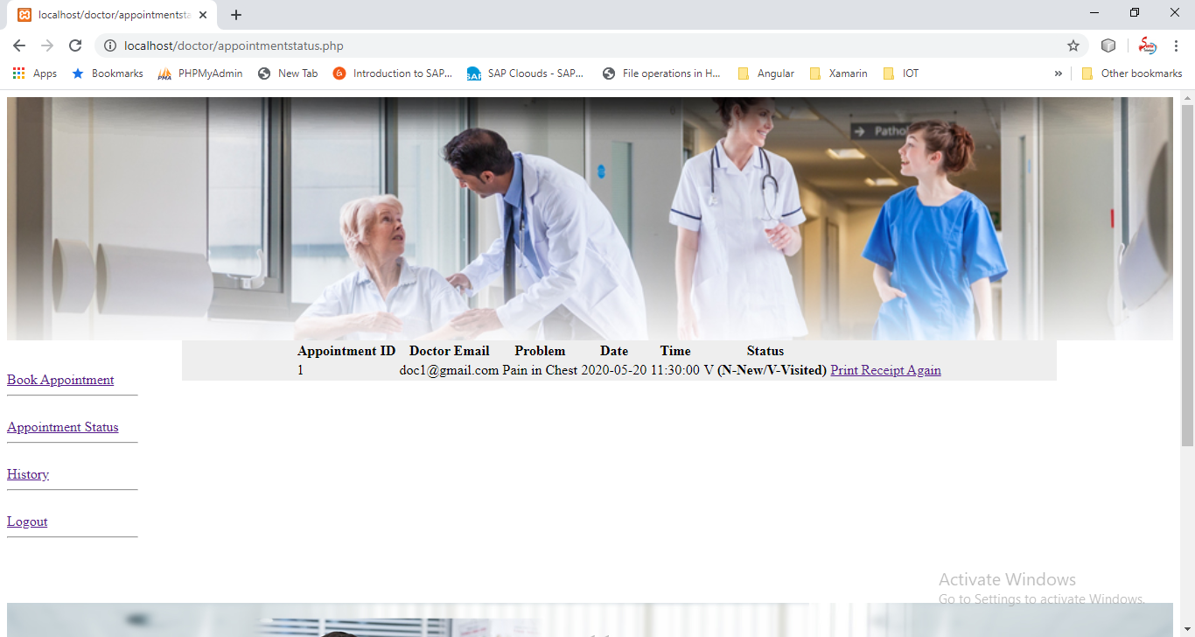

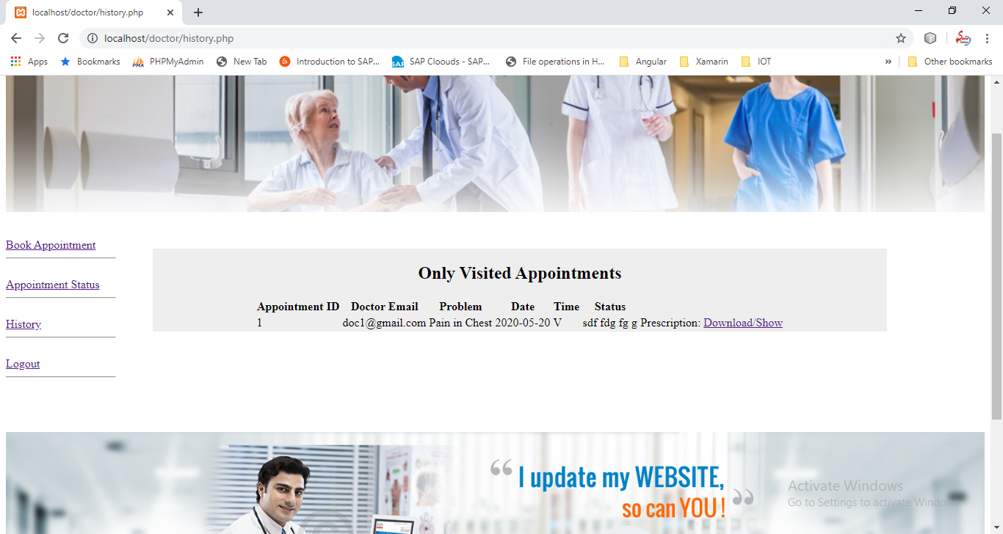

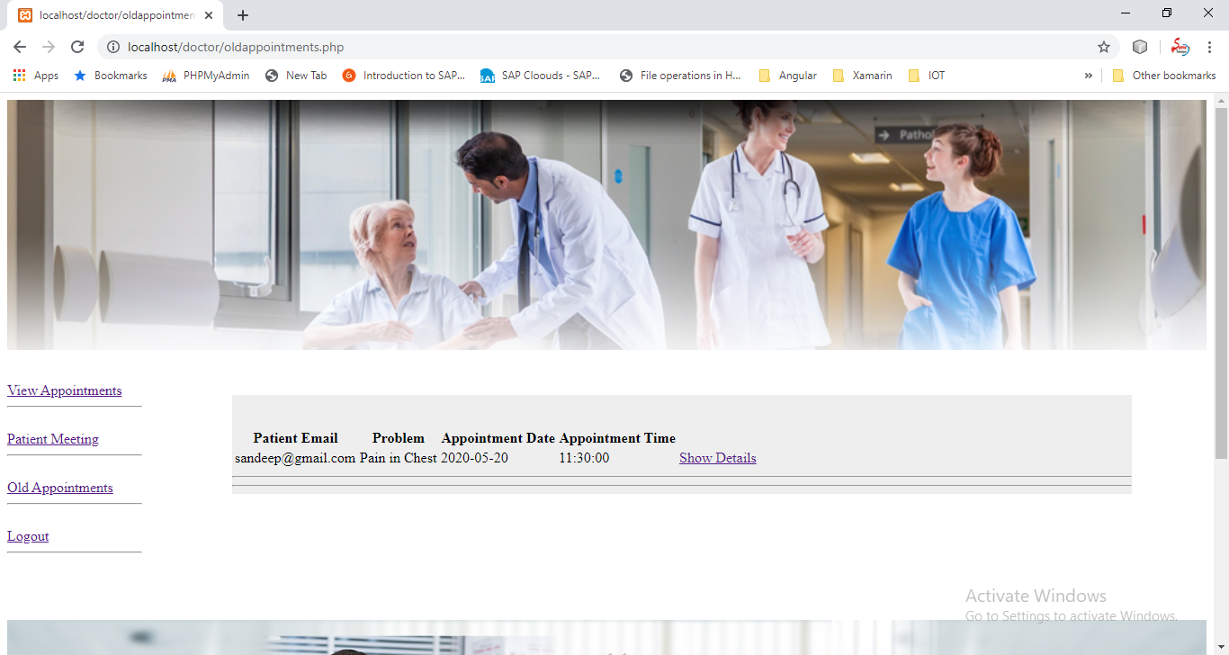

**Chapter 5**

**Technology Used**

PHP

## What is PHP?

* PHP is an acronym for "PHP: Hypertext Preprocessor"
* PHP is a widely-used, open source scripting language
* PHP scripts are executed on the server
* PHP is free to download and use

**PHP is an amazing and popular language!**

It is powerful enough to be at the core of the biggest blogging system on the web (WordPress)!  
It is deep enough to run the largest social network (Facebook)!  
It is also easy enough to be a beginner's first server side language!

## What is a PHP File?

* PHP files can contain text, HTML, CSS, JavaScript, and PHP code
* PHP code is executed on the server, and the result is returned to the browser as plain HTML
* PHP files have extension ".php"

## What Can PHP Do?

* PHP can generate dynamic page content
* PHP can create, open, read, write, delete, and close files on the server
* PHP can collect form data
* PHP can send and receive cookies
* PHP can add, delete, modify data in your database
* PHP can be used to control user-access
* PHP can encrypt data

With PHP you are not limited to output HTML. You can output images, PDF files, and even Flash movies. You can also output any text, such as XHTML and XML.

## Why PHP?

* PHP runs on various platforms (Windows, Linux, Unix, Mac OS X, etc.)
* PHP is compatible with almost all servers used today (Apache, IIS, etc.)
* PHP supports a wide range of databases
* PHP is free. Download it from the official PHP resource: [www.php.net](http://www.php.net/)
* PHP is easy to learn and runs efficiently on the server side

## What's new in PHP 7

* PHP 7 is much faster than the previous popular stable release (PHP 5.6)
* PHP 7 has improved Error Handling
* PHP 7 supports stricter Type Declarations for function arguments
* PHP 7 supports new operators (like the spaceship operator: <=> )

## PHP Variables

A variable can have a short name (like x and y) or a more descriptive name (age, carname, total_volume).

Rules for PHP variables:

* A variable starts with the $ sign, followed by the name of the variable
* A variable name must start with a letter or the underscore character
* A variable name cannot start with a number
* A variable name can only contain alpha-numeric characters and underscores (A-z, 0-9, and _ )
* Variable names are case-sensitive ($age and $AGE are two different variables)

## PHP Data Types

Variables can store data of different types, and different data types can do different things.

PHP supports the following data types:

* String
* Integer
* Float (floating point numbers - also called double)
* Boolean
* Array
* Object
* NULL
* Resource

## Features of PHP

The main features of php is; it is open source scripting language so you can free download this and use. PHP is a server site scripting language. It is open source scripting language. It is widely used all over the world. It is faster than other scripting language. Some important features of php are given below;

**Features of php**

It is most popular and frequently used world wide scripting language, the main reason of popularity is; It is open source and very simple.

* Simple
* Faster
* Interpreted
* Open Source
* Case Sensitive
* Simplicity
* Efficiency
* Platform Independent
* Security
* Flexibility
* Familiarity
* Error Reporting
* Loosely Typed Language
* Real-Time Access Monitoring

**Simple**

It is very simple and easy to use, compare to other scripting language it is very simple and easy, this is widely used all over the world.

**Interpreted**

It is an interpreted language, i.e. there is no need for compilation.

**Faster**

It is faster than other scripting language e.g. asp and jsp.

**Open Source**

Open source means you no need to pay for use php, you can free download and use.

**Platform Independent**

PHP code will be run on every platform, Linux, Unix, Mac OS X, Windows.

**Case Sensitive**

PHP is case sensitive scripting language at time of variable declaration. In PHP, all keywords (e.g. if, else, while, echo, etc.), classes, functions, and user-defined functions are NOT case-sensitive.

**Error Reporting**

PHP have some predefined error reporting constants to generate a warning or error notice.

**Real-Time Access Monitoring**

PHP provides access logging by creating the summary of recent accesses for the user.

**Loosely Typed Language**

PHP supports variable usage without declaring its data type. It will be taken at the time of the execution based on the type of data it has on its value.

**Chapter 6**

**Testing and Integration**

**6.1 Testing** :Software testing is the process of executing a program or system with the intent of finding errors. Or, it involves any activity aimed at evaluating an attribute or capability of a program or system and determining that it meet its required results. Software is not unlike other physical processes where inputs are received and output are produced. Where software differs is in the manner in which it is fails. Most physical systems fails in a fixed (and reasonable small) set of ways. By contrast, software can fail in many bizarre ways. Detecting all of the different failure modes for software is generally infeasible.

***Module testing:***

Here testing is done at each module level. Each case has been thoroughly tested to discover pitfalls.

***System testing:***

Here testing is done after all the modules have been integrated.

## Test Case Design

Test case design refers to how you set-up your test cases. It is important that your tests are designed well, or you could fail to identify bugs and defects in your software during testing.

There are many different test case design techniques used to test the functionality and various features of your software. Designing good test cases ensure that every aspect of your software gets tested so that you can find and fix any issues.

**A basic example of test case design:**

**Title:** Login to the website or app

**Description:** User should be able to successfully log in to their account on the website/app

**Preconditions:**User must already be registered and use their correct login details  
**Assumptions:** They are using a supported device or browser to log in  
**Test Steps:**

1. Open website or app
2. Enter the username and password in the appropriate fields
3. Click “login”

**Expected Result:** The user should log in successfully.

## What are the types of test case design techniques?

The main purpose of test case design techniques is to test the functionalities and features of the software with the help of effective test cases. The test case design techniques are broadly classified into three major categories.

1. Specification-Based techniques
2. Structure-Based techniques
3. Experience-Based techniques

### 6.2 Different Types Of Software Testing

*Given below is the list of some common types of Software Testing:*

**Functional Testing types include:**

* Unit Testing
* Integration Testing
* System Testing
* Sanity Testing
* Smoke Testing
* Interface Testing
* Regression Testing
* Beta/Acceptance Testing

**Non-functional Testing types include:**

* Performance Testing
* Load Testing
* Stress Testing
* Volume Testing
* Security Testing
* Compatibility Testing
* Install Testing
* Recovery Testing
* Reliability Testing
* Usability Testing
* Compliance Testing
* Localization Testing

#### #1) Alpha Testing

It is the most common type of testing used in the Software industry. The objective of this testing is to identify all possible issues or defects before releasing it into the market or to the user.

Alpha Testing is carried out at the end of the software development phase but before the Beta Testing. Still, minor design changes may be made as a result of such testing.

[Alpha Testing](https://www.softwaretestinghelp.com/what-is-alpha-testing-beta-testing/) is conducted at the developer’s site. In-house virtual user environment can be created for this type of testing.

#### #2) Acceptance Testing

An [Acceptance Test](https://www.softwaretestinghelp.com/what-is-acceptance-testing/) is performed by the client and verifies whether the end to end the flow of the system is as per the business requirements or not and if it is as per the needs of the end-user. Client accepts the software only when all the features and functionalities work as expected.

It is the last phase of the testing, after which the software goes into production. This is also called User Acceptance Testing (UAT).

#### #3) Ad-hoc Testing

The name itself suggests that this testing is performed on [an Ad-hoc](https://www.softwaretestinghelp.com/ad-hoc-testing/) basis i.e. with no reference to the test case and also without any plan or documentation in place for such type of testing.

The objective of this testing is to find the defects and break the application by executing any flow of the application or any random functionality.

Ad-hoc Testing is an informal way of finding defects and can be performed by anyone in the project. It is difficult to identify defects without a test case but sometimes it is possible that defects found during ad-hoc testing might not have been identified using existing test cases.

#### #4) Accessibility Testing

The aim of [Accessibility Testing](https://www.softwaretestinghelp.com/what-is-web-accessibility-testing/) is to determine whether the software or application is accessible for disabled people or not.

Here, disability means deaf, color blind, mentally disabled, blind, old age and other disabled groups. Various checks are performed such as font size for visually disabled, color and contrast for color blindness, etc.

#### #5) Beta Testing

[Beta Testing](https://www.softwaretestinghelp.com/beta-testing/) is a formal type of Software Testing which is carried out by the customer. It is performed in **the Real Environment**before releasing the product to the market for the actual end-users.

Beta Testing is carried out to ensure that there are no major failures in the software or product and it satisfies the business requirements from an end-user perspective. Beta Testing is successful when the customer accepts the software.

Usually, this testing is typically done by end-users or others. It is the final testing done before releasing an application for commercial purpose. Usually, the Beta version of the software or product released is limited to a certain number of users in a specific area.

So end-user actually uses the software and shares the feedback to the company. Company then takes necessary action before releasing the software to the worldwide.

#### #6) Back-end Testing

Whenever an input or data is entered on front-end application, it stores in the database and the testing of such database is known as Database Testing or Backend Testing.

There are different databases like SQL Server, MySQL, and Oracle, etc. Database Testing involves testing of table structure, schema, stored procedure, data structure and so on.

In Back-end Testing GUI is not involved, testers are directly connected to the database with proper access and testers can easily verify data by running a few queries on the database.

There can be issues identified like data loss, deadlock, data corruption etc during this back-end testing and these issues are critical to fixing before the system goes live into the production environment

#### #7) Browser Compatibility Testing

It is a subtype of Compatibility Testing (which is explained below) and is performed by the testing team.

[Browser Compatibility Testing](https://www.softwaretestinghelp.com/how-is-cross-browser-testing-performed/) is performed for web applications and it ensures that the software can run with the combination of different browser and operating system. This type of testing also validates whether web application runs on all versions of all browsers or not.

#### #8) Backward Compatibility Testing

It is a type of testing which validates whether the newly developed software or updated software works well with the older version of the environment or not.

Backward Compatibility Testing checks whether the new version of the software works properly with file format created by an older version of the software; it also works well with data tables, data files, data structure created by the older version of that software.

If any of the software is updated then it should work well on top of the previous version of that software.

#### #9) Black Box Testing

Internal system design is not considered in this type of testing. Tests are based on the requirements and functionality.

Detailed information about the advantages, disadvantages, and [types of Black box Testing](https://www.softwaretestinghelp.com/black-box-testing/) can be seen here.

#### #10) Boundary Value Testing

This type of testing checks the behavior of the application at the boundary level.

[Boundary Value Testing](https://www.softwaretestinghelp.com/what-is-boundary-value-analysis-and-equivalence-partitioning/) is performed for checking if defects exist at boundary values. Boundary Value Testing is used for testing a different range of numbers. There is an upper and lower boundary for each range and testing is performed on these boundary values.

If testing requires a test range of numbers from 1 to 500 then Boundary Value Testing is performed on values at 0, 1, 2, 499, 500 and 501.

#### #11) Branch Testing

It is a type of White box Testing and is carried out during Unit Testing. Branch Testing, the name itself suggests that the code is tested thoroughly by traversing at every branch.

#### #12) Comparison Testing

Comparison of a product's strength and weaknesses with its previous versions or other similar products is termed as Comparison Testing.

#### #13) Compatibility Testing

It is a testing type in which it validates how software behaves and runs in a different environment, web servers, hardware, and network environment.

[Compatibility testing](https://www.softwaretestinghelp.com/software-compatibility-testing/) ensures that software can run on a different configuration, different database, different browsers, and their versions. Compatibility testing is performed by the testing team.

#### #14) Component Testing

It is mostly performed by developers after the completion of unit testing. [Component Testing](https://www.softwaretestinghelp.com/what-is-component-testing-or-module-testing/) involves testing of multiple functionalities as a single code and its objective is to identify if any defect exists after connecting those multiple functionalities with each other.

#### #15) End-to-End Testing

Similar to system testing, [End-to-End Testing](https://www.softwaretestinghelp.com/what-is-end-to-end-testing/) involves testing of a complete application environment in a situation that mimics real-world use, such as interacting with a database, using network communications, or interacting with other hardware, applications, or systems if appropriate.

#### #16) Equivalence Partitioning

It is a testing technique and a type of Black Box Testing. During this [Equivalence Partitioning](https://www.softwaretestinghelp.com/what-is-boundary-value-analysis-and-equivalence-partitioning/), a set of the group is selected and a few values or numbers are picked up for testing. It is understood that all values from that group generate the same output.

The aim of this testing is to remove redundant test cases within a specific group which generates the same output but not any defect.

Suppose, the application accepts values between -10 to +10 so using equivalence partitioning the values picked up for testing are zero, one positive value, one negative value. So the Equivalence Partitioning for this testing is  -10 to -1, 0, and 1 to 10.

#### #17) Example Testing

It means real-time testing. Example Testing includes the real-time scenario, it also involves the scenarios based on the experience of the testers.

#### #18) Exploratory Testing

Exploratory Testing is informal testing performed by the testing team. The objective of this testing is to explore the application and looking for defects that exist in the application.

Sometimes it may happen that during this testing major defect discovered can even cause a system failure.

During Exploratory Testing, it is advisable to keep a track of what flow you have tested and what activity you did before the start of the specific flow.

[An Exploratory Testing technique](https://www.softwaretestinghelp.com/what-is-exploratory-testing/) is performed without documentation and test cases.

#### #20) Functional Testing

This type of testing ignores the internal parts and focuses only on the output to check if it is as per the requirement or not. It is a Black-box type testing geared to the functional requirements of an application. For detailed information about Functional Testing click [here](https://www.softwaretestinghelp.com/guide-to-functional-testing/).

#### #21) Graphical User Interface (GUI) Testing

The objective of this GUI Testing is to validate the GUI as per the business requirement. The expected GUI of the application is mentioned in the Detailed Design Document and GUI mockup screens.

The GUI Testing includes the size of the buttons and input field present on the screen, alignment of all text, tables, and content in the tables.

It also validates the menu of the application, after selecting different menu and menu items, it validates that the page does not fluctuate and the alignment remains same after hovering the mouse on the menu or sub-menu.

#### #22) Gorilla Testing

Gorilla Testing is a testing type performed by a tester and sometimes by the developer the as well. In Gorilla Testing, one module or the functionality in the module is tested thoroughly and heavily. The objective of this testing is to check the robustness of the application.

#### #23) Happy Path Testing

The objective of Happy Path Testing is to test an application successfully on a positive flow. It does not look for negative or error conditions. The focus is only on the valid and positive inputs through which application generates the expected output.

#### #24) Incremental Integration Testing

[Incremental Integration Testing](https://www.softwaretestinghelp.com/incremental-testing/) is a Bottom-up approach for testing i.e continuous testing of an application when new functionality is added. Application functionality and modules should be independent enough to test separately. This is done by programmers or by testers.

#### #25) Install/Uninstall Testing

[Installation and Uninstallation Testing](https://www.softwaretestinghelp.com/software-installationuninstallation-testing/) is done on full, partial, or upgrade install/uninstall processes on different operating systems under different hardware or software environment.

#### #26) Integration Testing

Testing of all integrated modules to verify the combined functionality after integration is termed as[Integration Testing](https://www.softwaretestinghelp.com/what-is-integration-testing/).

Modules are typically code modules, individual applications, client and server applications on a network, etc. This type of testing is especially relevant to client/server and distributed systems.

#### #27) Load Testing

It is a type of Non-Functional Testing and the objective of Load Testing is to check how much load or maximum workload a system can handle without any performance degradation.

[Load Testing helps](https://www.softwaretestinghelp.com/introduction-to-performance-testing-loadrunner-training-tutorial-part-1/) to find the maximum capacity of the system under specific load and any issues that cause software performance degradation. Load testing is performed using tools like[JMeter](https://www.softwaretestinghelp.com/jmeter-tutorials/), LoadRunner, WebLoad, Silk performer, etc.

#### #28) Monkey Testing

[Monkey Testing](https://www.softwaretestinghelp.com/what-is-monkey-testing-in-software-testing/) is carried out by a tester assuming that if the monkey uses the application then how random input, values will be entered by the Monkey without any knowledge or understanding of the application.

The objective of Monkey Testing is to check if an application or system gets crashed by providing random input values/data. Monkey Testing is performed randomly and no test cases are scripted and it is not necessary to

Monkey Testing is performed randomly and no test cases are scripted and it is not necessary to be aware of the full functionality of the system.

#### #29) Mutation Testing

[Mutation Testing](https://www.softwaretestinghelp.com/what-is-mutation-testing/) is a type of white box testing in which the source code of one of the program is changed and verifies whether the existing test cases can identify these defects in the system.

The change in the program source code is very minimal so that it does not impact the entire application, only the specific area having the impact and the related test cases should able to identify those errors in the system.

#### #30) Negative Testing

Testers having the mindset of “attitude to break” and using Negative Testing they validate that if system or application breaks. [A Negative Testing technique](https://www.softwaretestinghelp.com/what-is-negative-testing/) is performed using incorrect data, invalid data or input. It validates that if the system throws an error of invalid input and behaves as expected.

#### #31) Non-Functional Testing

It is a type of testing for which every organization having a separate team which usually called as Non-Functional Test (NFT) team or Performance team.

[Non-Functional Testing](https://www.softwaretestinghelp.com/what-is-non-functional-testing/)involves testing of non-functional requirements such as Load Testing, Stress Testing, Security, Volume, Recovery Testing, etc. The objective of NFT testing is to ensure whether the response time of software or application is quick enough as per the business requirement.

It should not take much time to load any page or system and should sustain during peak load.

#### #32) Performance Testing

This term is often used interchangeably with ‘stress' and ‘load' testing. [Performance Testing](https://www.softwaretestinghelp.com/introduction-to-performance-testing-loadrunner-training-tutorial-part-1/) is done to check whether the system meets the performance requirements. Different performance and load tools are used to do this testing.

#### #33) Recovery Testing

It is a type of testing which validates how well the application or system recovers from crashes or disasters.

Recovery Testing determines if the system is able to continue the operation after a disaster. Assume that application is receiving data through the network cable and suddenly that network cable has been unplugged.

Sometime later, plug the network cable; then the system should start receiving data from where it lost the connection due to network cable unplugged.

#### #34) Regression Testing

Testing an application as a whole for the modification in any module or functionality is termed as Regression Testing. It is difficult to cover all the system in [Regression Testing](https://www.softwaretestinghelp.com/regression-testing-tools-and-methods/), so typically [Automation Testing Tools](https://www.softwaretestinghelp.com/automation-testing-tutorial-1/) are used for these types of testing.

#### #35) Risk-Based Testing (RBT)

In [Risk-Based Testing](https://www.softwaretestinghelp.com/risk-management-during-test-planning-risk-based-testing/), the functionalities or requirements are tested based on their priority. Risk-Based Testing includes testing of highly critical functionality, which has the highest impact on business and in which the probability of failure is very high.

The priority decision is based on the business need, so once priority is set for all functionalities then high priority functionality or test cases are executed first followed by medium and then low priority functionalities.

The low priority functionality may be tested or not tested based on the available time.

The Risk-Based Testing is carried out if there is insufficient time available to test entire software and software needs to be implemented on time without any delay. This approach is followed only by the discussion and approval of the client and senior management of the organization.

#### #36) Sanity Testing

[Sanity Testing](https://www.softwaretestinghelp.com/smoke-testing-and-sanity-testing-difference/) is done to determine if a new software version is performing well enough to accept it for a major testing effort or not. If an application is crashing for the initial use then the system is not stable enough for further testing. Hence a build or an application is assigned to fix it.

#### #37) Security Testing

It is a type of testing performed by a special team of testers. A system can be penetrated by any hacking way.

[Security Testing](https://www.softwaretestinghelp.com/how-to-test-application-security-web-and-desktop-application-security-testing-techniques/) is done to check how the software or application or website is secure from internal and external threats. This testing includes how much software is secure from the malicious program, viruses and how secure and strong the authorization and authentication processes are.

It also checks how software behaves for any hackers attack and malicious programs and how software is maintained for data security after such a hacker attack.

#### #38) Smoke Testing

Whenever a new build is provided by the development team then the Software Testing team validates the build and ensures that no major issue exists.

The testing team ensures that the build is stable and a detailed level of testing is carried out further. [Smoke Testing](https://www.softwaretestinghelp.com/smoke-testing-and-sanity-testing-difference/) checks that no show stopper defect exists in the build which will prevent the testing team to test the application in detail.

If testers find that the major critical functionality is broken down at the initial stage itself then testing team can reject the build and inform accordingly to the development team. Smoke Testing is carried out to a detailed level of any Functional or Regression Testing.

#### #39) Static Testing

Static Testing is a type of testing which is executed without any code. The execution is performed on the documentation during the testing phase.

It involves reviews, walkthrough, and inspection of the deliverables of the project. Static Testing does not execute the code instead of the code syntax, naming conventions are checked.

[Static Testing](https://www.softwaretestinghelp.com/static-testing-and-dynamic-testing-difference/) is also applicable for test cases, test plan, design document. It is necessary to perform static testing by the testing team as the defects identified during this type of testing are cost-effective from the project perspective.

#### #40) Stress Testing

This testing is done when a system is stressed beyond its specifications in order to check how and when it fails. This is performed under heavy load like putting large number beyond storage capacity, complex database queries, continuous input to the system or database load.

#### #41) System Testing

Under [System Testing technique](https://www.softwaretestinghelp.com/system-testing/), the entire system is tested as per the requirements. It is a Black-box type Testing that is based on overall requirement specifications and covers all the combined parts of a system.

#### #42) Unit Testing

Testing of an individual software component or module is termed as [Unit Testing](https://www.softwaretestinghelp.com/unit-testing/). It is typically done by the programmer and not by testers, as it requires detailed knowledge of the internal program design and code. It may also require developing test driver modules or test harnesses.

#### #43) Usability Testing

Under [Usability Testing](https://www.softwaretestinghelp.com/usability-testing-guide/), User-friendliness check is done. The application flow is tested to know if a new user can understand the application easily or not, Proper help documented if a user gets stuck at any point. Basically, system navigation is checked in this testing.

#### #44) Vulnerability Testing

The testing which involves identifying weakness in the software, hardware and the network is known as Vulnerability Testing. Malicious programs, the hacker can take control of the system, if it is vulnerable to such kind of attacks, viruses, and worms.

So it is necessary to check if those systems undergo Vulnerability Testing before production. It may identify critical defects, flaws in the security.

#### #45) Volume Testing

[Volume Testing](https://www.softwaretestinghelp.com/what-is-volume-testing/) is a type of Non-Functional Testing performed by the Performance Testing team.

The software or application undergoes a huge amount of data and Volume Testing checks the system behavior and response time of the application when the system came across such a high volume of data. This high volume of data may impact the system’s performance and speed of the processing time.

#### #46) White Box Testing

[White Box Testing](https://www.softwaretestinghelp.com/white-box-testing-techniques-with-example/) is based on the knowledge about the internal logic of an application's code.

It is also known as Glass box Testing. Internal software and code working should be known for performing this type of testing. Under these tests are based on the coverage of code statements, branches, paths, conditions, etc.

***IMPLEMENTATION***

The implementation phase is less creative than system design. It is primarily concerned with user training, site preparation and file conversion. During file testing, user acceptance is, tested followed by user training. Depending on the nature of system, extensive user training may be required. Conversion usually takes place at about the same time the user is being trained. Programming is thought to be modified as a result of programming effort. Programming provides a ***“realty test”*** for the assumption made by analyst.

System testing checks the deadlines and accuracy of the system. To access, update and retrieve data from new files. Once the programs become available, test data are read into the computer and processed against the file provided. For testing, it successful program is then run with ***“live”*** data. Otherwise, a diagnostic test to locate and correct errors. In most conversion, parallel run is conducted where the new system simultaneous run both old system. This method, through costly, provided added assurance against errors in the candidate system. This method through costly, provided added assurance against errors in the candidate system and also the user staff an opportunity to gain experience through operation.

***FUTURE SCOPE***

The future of this project depend on whether the author has enough spare time over the next 2 month to continue with the developing. The author feels that last few remaining features would round off the system. If the author was to try to sell this system then more system testing would have to be done, in a particular a more comprehensive real – world. Testing environment would have to be adopted along with some real words usage. Multiple concurrent users would be command in real world usage but have been difficult to test for considering there was only tester involved in this project. This type of system would benefit for the hardware in case of a system failure for the software in case of newly found bugs, in return of a subscription free.

***BIBLIOGRAPHY/ REFERENCES***

***PHP TUTORIAL***

[***WWW.W3SCHOOLS.COM***](http://WWW.W3SCHOOLS.COM)

[***WWW.TUTORIALPOINT.COM***](http://WWW.TUTORIALPOINT.COM)

***Learn PHP in 21 Days***

***Tata Macgraw Hill (Evan Bayross)***

***[1] Arthur Hylton III and Suresh Sankaran arayanan “Application of Intelligent Agents in Hospital Appointment Scheduling System”, International Journal of Computer Theory and Engineering, Vol. 4, August 2012, pp. 625-630.***

***[2] Deepti Ameta, Kalpana Mudaliar and Palak Patel “Medication Reminder And Healthcare – An Android Application”, International Journal of Managing Public Sector Information and Communication Technologies (IJMPICT) Vol. 6, June 2015, pp. 39-48.***

***[3] Yeo Symey, Suresh Sankaran arayanan, Siti Nurafifah binti Sait “Application of Smart Technologies for Mobile Patient Appointment System”, International Journal of Advanced Trends in Computer Science and Engineering, august 2013.***

***[4] Jagannath Aghav, Smita Sonawane, and Himanshu Bhambhlani “Health Track: Health Monitoring and Prognosis System using Wearable Sensors”, IEEE International Conference on Advances in Engineering & Technology Research 2014, pp. 1-5.***

***[5] YoeSyMey and Suresh Sankaranarayanan “Near Field Communication based Patient Appointment”, InternatiConference on Cloud and Ubiquitous Computing and Emerging Technologies, 2013, pp.98-103.***

***[6] RashmiA.Nimbalkar and R.A. Fadnavis “Domain Specific Search of Nearest Hospital and Healthcare Management System”, Recent Advances in Engineering and Computational Sciences (RAECS), 2014, pp.1-5.***

***[7}A. Luschi, A. Belardinelli, L. Marzi, F. Frosini, R. Miniati and E. Iadanza “Careggi Smart Hospital: a mobile app for patients, citizens and healthcare staff”, IEEE-EMBS International Conference on Biomedical and Health informatics (BHI), 2014, pp.125-128.***

***[8] Choi, J. ; Biomed lab Co., Seoul, South Korea ; Kang, W.Y. ; Chung, J. ; Park, J.W. “Development Of An Online Database System For Remote Monitoring Of Artificial Heart Patient”,Information Technology Applications in Biomedicine, 2003. 4th International IEEE EMBS Special Topic Conference, 24-26 April 2003***

***[9] Prof. S. B. Choudhari, ChaitanyaKusurkar, RuchaSonje, ParagMahajan, Joanna Vaz “Android Application for Doctor‟s Appointment”, International Journal of Innovative Research in Computer and Communication Engineering, January 2014***

***[10] S.Gavaskar, A. Sumithra, A.Saranya “Health Portal-An Android Smarter Healthcare Application”, International Journal of Research in Engineering and Technology, Sep-2013.***

***[11]Frank Sposaro and Gary Tyson, “iFall: An android application for fall monitoring and response”, 31st Annual International Conference of the IEEE Engineering in Medicine and Biology Society, 1:6119–22, 2009.***

***[12] Pei-Fang Tsai, I-sheng Chen, and Keven Pothoven “Development of Handheld Healthcare Information System in an Outpatient Physical Therapy Clinic”, proceedings of the 2014 IEEE 18th International Conference on Computer Supported Cooperative Work in Design, pp. 559-602.***

***[13] Jin Wang, Richard Y.K. Fung “adaptive dynamic programming algorithms for sequential appointment scheduling with patient preferences”, Science Direct, Artificial Intelligence in MedicineJanuary 2015, Pages 33–40***

***[14] Bin Mu, Feng Xiao, Shijin Yuan “A Rule-based Disease Self-inspection and Hospital Registration Recommendation System”, Software Engineering and Service Science (ICSESS), 2012 IEEE 3rd International Conference, 22-24 June 2012***

***CONCLUSION***

The final section of the Project is the Conclusion section. Briefly summarize the overall conclusion of the data analysis based on the purpose of the study. Also explain the importance of the major finding to educational practice.

***THANK***

***YOU***